自有題庫匯入google表單測驗流程
- 新增google 試算表
- 匯入即有EXCEL檔或自行建立題庫檔如以下格式(最後一欄10為配分)
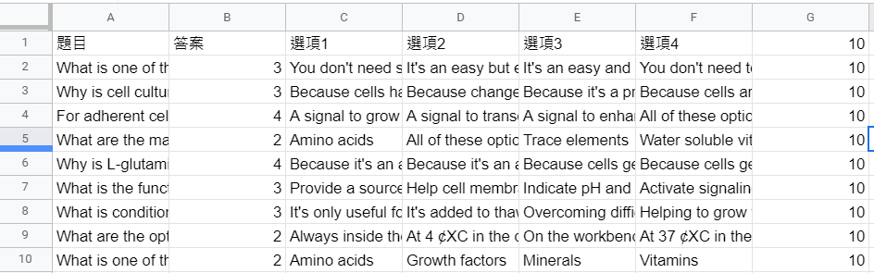
- 點選 [工具] 🡪 [指令碼編輯器]
- 刪除原有指令 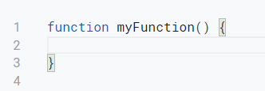
- 貼上以下新指令
function popForm() {

var ss = SpreadsheetApp.getActive();
var sheet = ss.getActiveSheet();
//var sheet = ss.getSheetByName('Sheet1');
var numberRows = sheet.getDataRange().getNumRows();
// Read the sheet data into 3 arrays. Would be better practice (faster performance) to read all into 1 array and divide as needed).
var myQuestions = sheet.getRange(1,1,numberRows,1).getValues();
var myAnswers = sheet.getRange(1,2,numberRows,1).getValues();
var myPoints = sheet.getRange(1,7,numberRows,1).getValues();
var myGuesses = sheet.getRange(1,3,numberRows,4).getValues();

// Shuffle the 5 choices horizontally. This script only works with Questions in col A, correct Answer in col B, and false choices in col C thru F.
var myShuffled = myGuesses.map(shuffleEachRow);

// Create the form as a quiz. The resulting form's "Quiz options" are different from a manually created quiz. Be aware (and change manually if needed!
//var form = FormApp.create('States and Capitals Quiz');
var form=FormApp.create(sheet.getName());
form.setIsQuiz(true);
form.setShuffleQuestions(true);

var itemNameInput=form.addTextItem();
itemNameInput.setTitle("請輸入班級代碼：");
itemNameInput.setRequired(true);

var itemNameInput=form.addTextItem();
itemNameInput.setTitle("請輸入學號：");
itemNameInput.setRequired(true);

var itemNameInput=form.addTextItem();
itemNameInput.setTitle("請輸入姓名：");
itemNameInput.setRequired(true);

var pb1=form.addPageBreakItem();
pb1.setTitle(sheet.getName());

// Write out each multiple choice question to the form.
for(var i=0;i<numberRows;i++){
var myItem=form.addMultipleChoiceItem();
myItem.setTitle(myQuestions[i][0]);
myItem.setPoints(myPoints[i][0]);
myItem.setRequired(true);

if(myShuffled[i][2]==""){
if(myAnswers[i][0]==1 || myAnswers[i][0]=="１"){

myItem.setChoices([
myItem.createChoice(myShuffled[i][0],true),
myItem.createChoice(myShuffled[i][1]),

]);
}else if(myAnswers[i][0]==2 || myAnswers[i][0]=="２"){
myItem.setChoices([
myItem.createChoice(myShuffled[i][0]),
myItem.createChoice(myShuffled[i][1],true),

]);
}else{

}
}else if(myShuffled[i][3]==""){
if(myAnswers[i][0]==1 || myAnswers[i][0]=="１"){

myItem.setChoices([
myItem.createChoice(myShuffled[i][0],true),
myItem.createChoice(myShuffled[i][1]),
myItem.createChoice(myShuffled[i][2]),
]);
}else if(myAnswers[i][0]==2 || myAnswers[i][0]=="２"){
myItem.setChoices([
myItem.createChoice(myShuffled[i][0]),
myItem.createChoice(myShuffled[i][1],true),
myItem.createChoice(myShuffled[i][2]),
]);
}else if(myAnswers[i][0]==3 || myAnswers[i][0]=="３"){
myItem.setChoices([
myItem.createChoice(myShuffled[i][0]),
myItem.createChoice(myShuffled[i][1]),
myItem.createChoice(myShuffled[i][2],true),
]);
}else{

}
}else{
if(myAnswers[i][0]==1 || myAnswers[i][0]=="１"){

myItem.setChoices([
myItem.createChoice(myShuffled[i][0],true),
myItem.createChoice(myShuffled[i][1]),
myItem.createChoice(myShuffled[i][2]),
myItem.createChoice(myShuffled[i][3]),
]);
}else if(myAnswers[i][0]==2 || myAnswers[i][0]=="２"){
myItem.setChoices([
myItem.createChoice(myShuffled[i][0]),
myItem.createChoice(myShuffled[i][1],true),
myItem.createChoice(myShuffled[i][2]),
myItem.createChoice(myShuffled[i][3]),
]);
}else if(myAnswers[i][0]==3 || myAnswers[i][0]=="３"){
myItem.setChoices([
myItem.createChoice(myShuffled[i][0]),
myItem.createChoice(myShuffled[i][1]),
myItem.createChoice(myShuffled[i][2],true),
myItem.createChoice(myShuffled[i][3]),
]);
}else{
myItem.setChoices([
myItem.createChoice(myShuffled[i][0]),
myItem.createChoice(myShuffled[i][1]),
myItem.createChoice(myShuffled[i][2]),
myItem.createChoice(myShuffled[i][3],true),
]);
}
}

var oldChoices=myItem.getChoices();
var newChoices=shuffle(oldChoices);
myItem.setChoices(newChoices);

}
}

function shuffle(array) {
for (var i = array.length - 1; i > 0; i--) {
var j = Math.floor(Math.random() * (i + 1));
var temp = array[i];
array[i] = array[j];
array[j] = temp;
}
return array;
}

// This function, called by popForm, shuffles the 5 choices.
function shuffleEachRow(array) {
var i, j, temp;
for (i = array.length - 1; i > 0; i--) {
/*
j = Math.floor(Math.random() * (i + 1));
temp = array[i];
array[i] = array[j];
array[j] = temp;
*/
}
return array;
}
//修改自 陳東甫 & Golden GAS Script Google Form from Sheets​

- 點選 [儲存專案] 🡪 [執行]
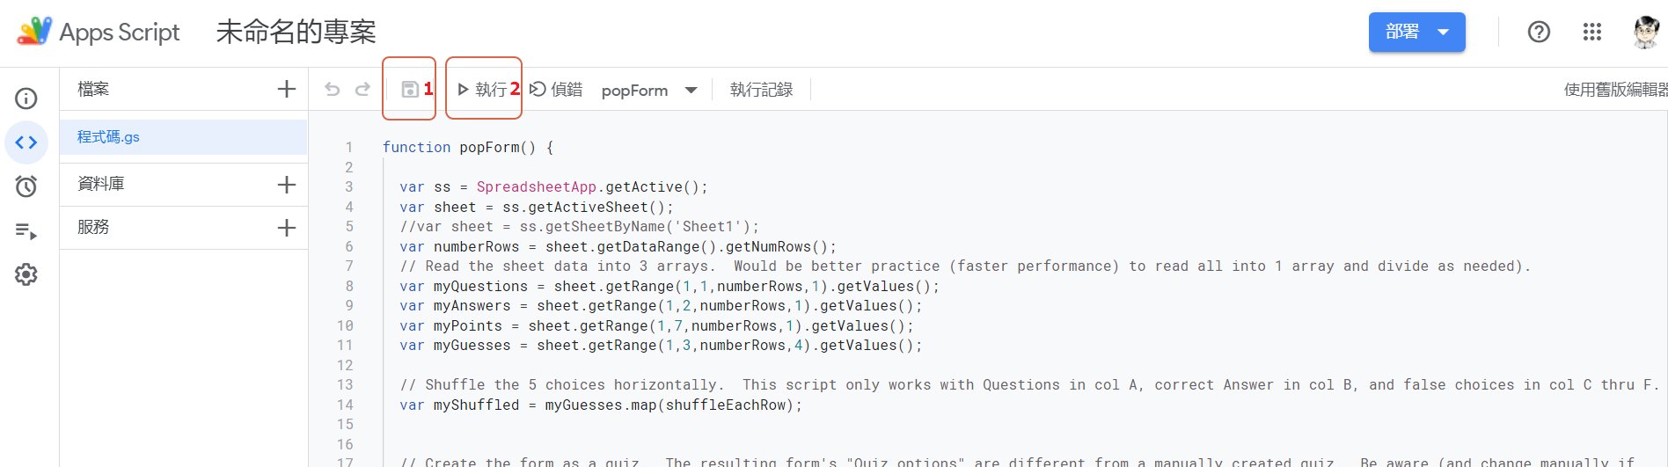
- 梢等一回, 點選審查授權
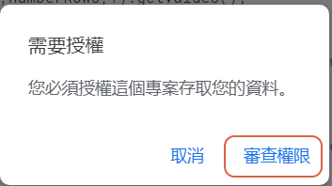

- 點選授權帳號 🡪 允許

- 開始執行 🡪 等待執行完畢
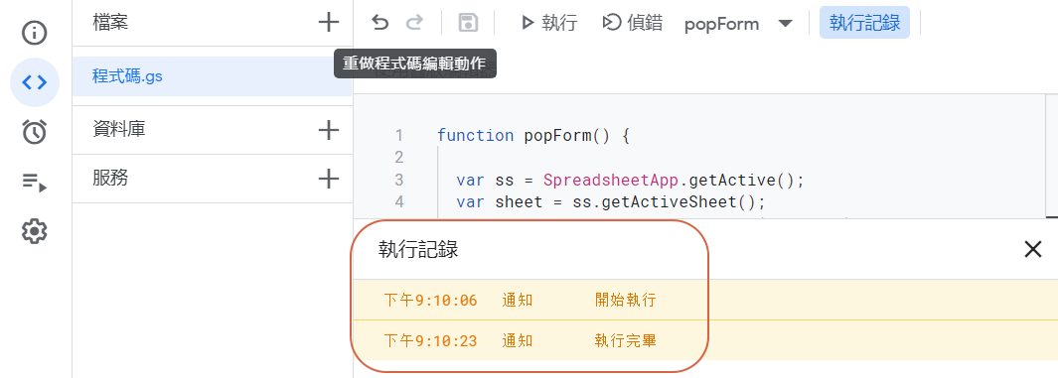
- 查看雲端硬碟，找到新出現的表單 🡪 點選開啟

- 點選右上角齒輪[設定] 🡪 點測驗 🡪 自行勾選最下方”作答者可以查看” 🡪 儲存 🡪 google 表單試卷完工。

